**1. Basic Printing**

* **Write a Python script to print the phrase 'Hello, World!'**

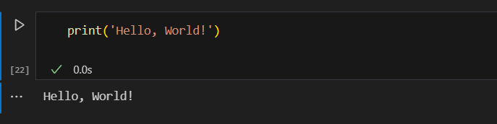

* **Print your first name**

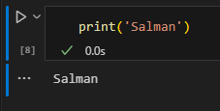

**2. Printing Multiple Items**

* **Print your first name and last name in a single print statement**

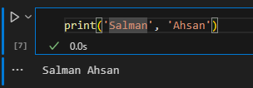

* **Print the numbers 1, 2, and 3 in a single print statement**

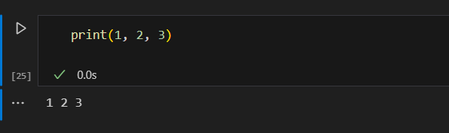

**3. Printing Special Characters**

* **Print a string that includes a newline character to display text on two lines**

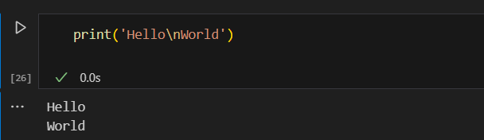

* **Print a string that includes a tab character**

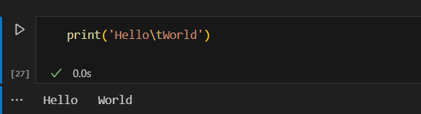

**4. Using the sep Parameter**

* **Print three different words separated by commas**

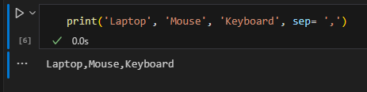

* **Print three different numbers separated by hyphens**

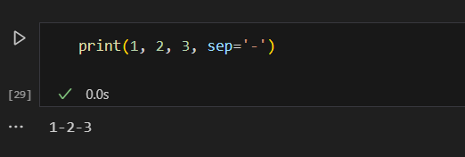

**5. Using the end Parameter**

* **Print two words on the same line with a space in between**

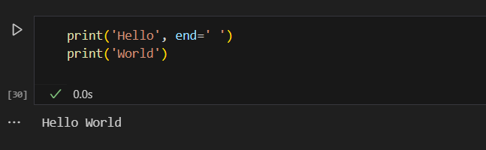

* **Print the numbers 1 and 2 on the same line without a space in between**

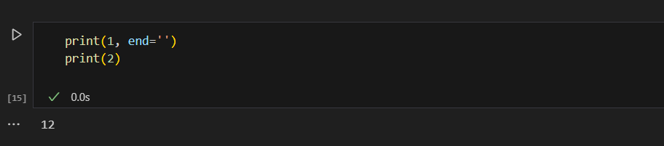

**6. Escape Characters**

* **Print a string that includes double quotes**

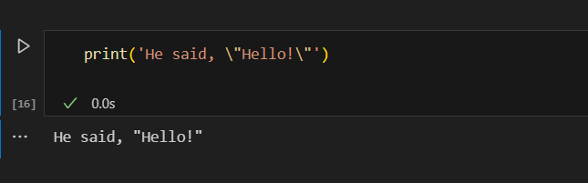

* **Print a backslash character**

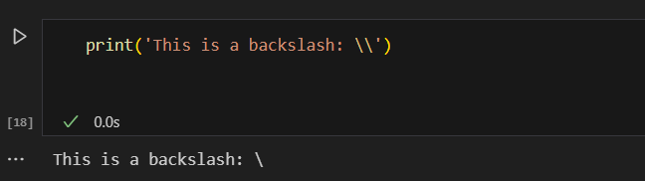

**7. Combining Text and Numbers**

* **Print your age alongside a descriptive message**

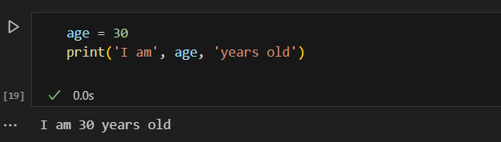

* **Print a number and a string together**

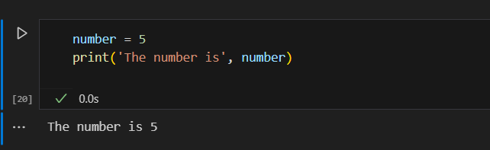

**8. Basic Loop for Printing**

* **Print the numbers 1 to 5, each on a new line using separate print statements**

